**CS390S Assignment 2 (10 points + bonus)**

**Requirements:**

1. **Apply Averaging filter, Sobel filter, Laplacian filter, Median filter to one of your own images. Show the original image and filtered images in your report.**

For each type of filter, you could choose any kernel size, any center type (positive or negative).

You are NOT required to analyze the different effects of the filters, just observe and show the filtering results in the report.

The filter kernels must be generated by **your own program**, any type of function to generate a filter kernel is not allowed. However, functions that perform 2D filtering or convolution are accepted.

1. **Bonus (2 points)**

**Apply any type of filter other than those listed above to one of your own images. Show the original image and filtered images in your report.**

**And analyze the filtering result.**

The filter kernels must be generated by **your own program**, any type of function to generate a filter kernel is not allowed. However, functions that perform 2D filtering or convolution are accepted.

1. **Download image “iris.bmp” from blackboard. Find the boundary of the pupil in this image, *given that the radius of the pupil should be within range 35-45 pixels in the image*. Show the original image and detected boundary of the pupil in your report.**

*Suggested approach (not required):*

*Detect the edge of this image using “Sobel Filter” as shown below. Design a filter kernel that big enough to cover the pupil and use it to convolve with the edge image. Detect the center of the pupil by thresholding and mask out noisy edges outside the pupil radius range (45).*

The boundary of the pupil must be detected by **your own program**, functions that detect circles (such as “imfindcircles” in matlab, “HoughCircles” in OpenCV) are NOT allowed. However, other functions that perform 2D filtering or convolution, image preprocessing, image enhancement etc. are accepted.

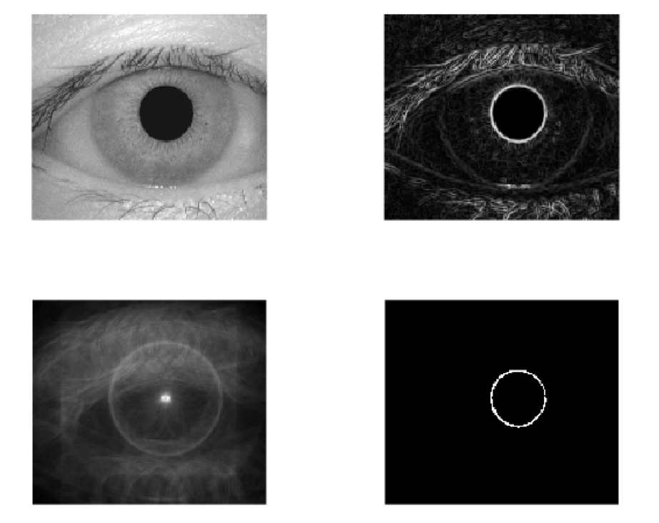

*Example Approach*

**What to submit:**

1. **Your report “Firstname_Lastname_HW2.docx/doc” or “Firstname_Lastname_HW2.pdf”**

In your report, please include the input and output images and a brief discussion of your design or explanation of your code.

1. **A compressed “.zip” file** (NO “.rar” files accepted) including all the source code files and source images, output images, “read me” file or other support files to run your code.

* Students using Python need clearly specify what libraries are used in your report (and “imported” in your .py code files).
* Python source code must be submitted using “.py” extension (“.ipynb” files are not accepted).
* Image path in the source code must be relative path (e.g. “./iris.bmp” or “./image/iris.bmp”). **Absolute input/output path such as “C:/image/iris.bmp” is NOT accepted.**
* Resubmissios are accepted only:

1. Draft version (80% work is done) is submitted before deadline.

2. Resubmission is submitted within one week after the deadline.